**Effect of Healthcare Quality on Happiness**

By Neelam Patel, Tina Huang, Victoria Grose, & Vadym Zhukhovytskyy

**Global Happiness**

According to the region breakdown boxplot (Figure 2), Western Europe has the highest happiness scores and Sub-Saharan Africa has the lowest. Countries with the highest happiness include Scandinavia (Finland, Norway, and Sweden), Denmark, Canada, Switzerland and Australia.

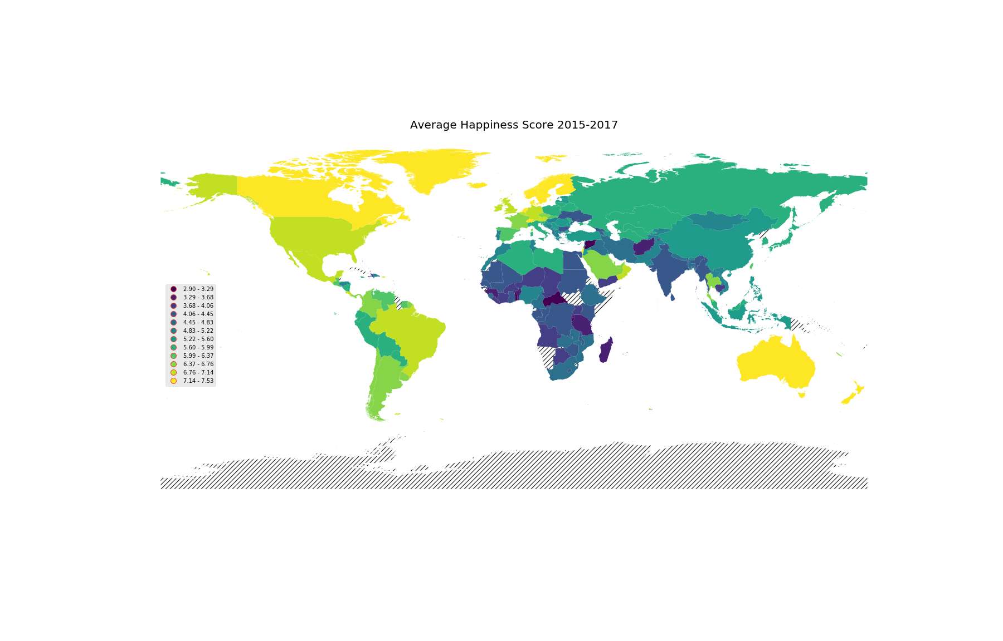

Figure 1 Happiness World Map

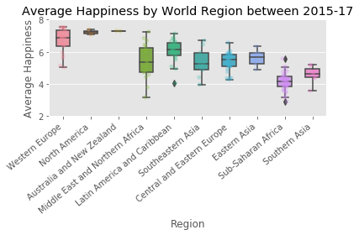

Figure 2 Happiness Box Plot

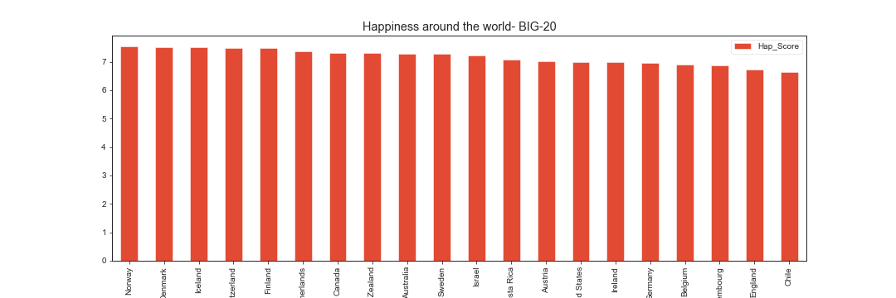

Figure 3 Happiness Scores of Top 20 Countries

**Healthcare Resources and Happiness**

Happiness is highest correlated with life expectancy (r=0.77). Both measures are highest in western Europe and lowest in sub-Saharan Africa.

Availability of medical care is the second highest correlate with overall happiness. Of the 4 aspects of healthcare quality we examined, number of physicians and nurses/midwives per capita correlated positively with happiness (r=0.48). This suggests that availability and accessibility of medical resources contributes to overall happiness. High medical expense does not necessarily lead to lower happiness (r=0.3) or longer life expectancy (r=0.3).

Lowest happiness level is observed in a sub-Saharan country with low life expectancy and relatively high medical expenditure (~9.5% GDP). Additionally, the health care expenditure in the United States (far right orange bubble) is not proportional to the happiness and life expectancy. High medical expenditure does not necessarily lead to higher medical quality, higher life expectancy, or higher overall happiness.

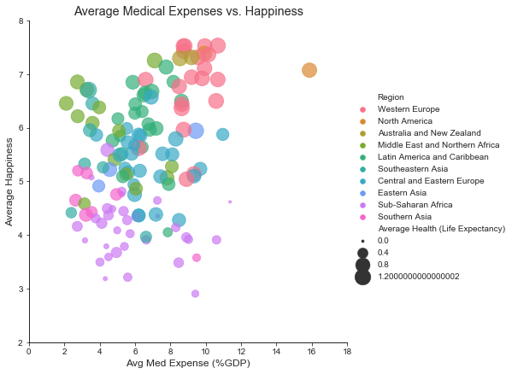

Figure Medical Expense Scatter Plot

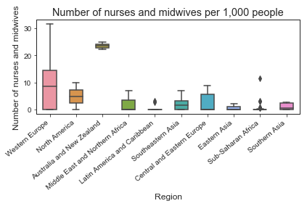

Figure Nurses/Midwives Boxplot

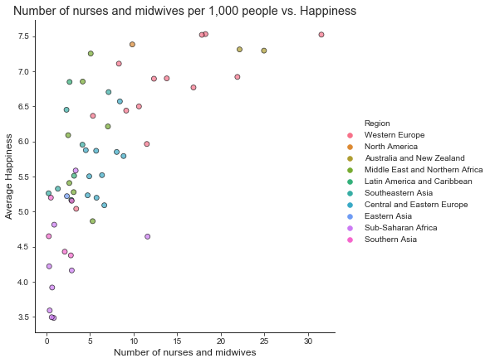

Figure Nurses/Midwives Scatterplot

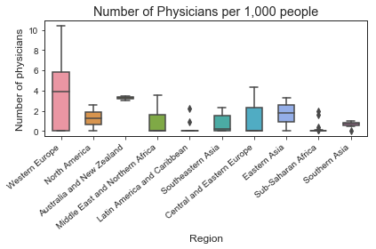

Figure Physicians Boxplot

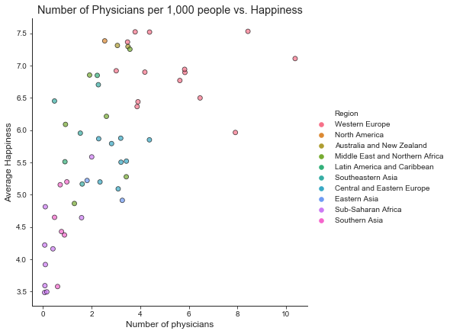

Figure Physicians Scatter Plot

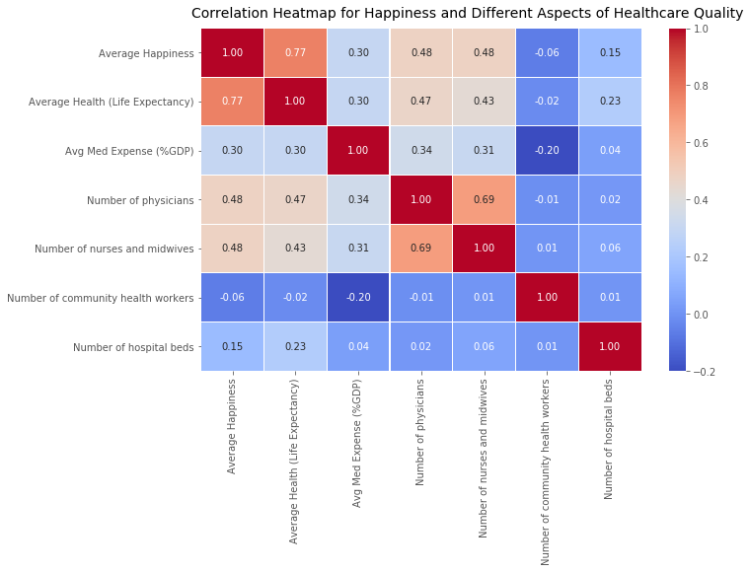

Figure Correlation heatmap

**Healthcare Expenditure and Happiness**

The Happiness Score is already accounting multiple factors such as Economy, Family, Health (Life Expectancy), Freedom, Trust (Government Corruption), Generosity, and Dystopia Residual. We wanted to see that even after the happiness score was determined for each country, was there any correlation with the happiness and health expenditure.

After comparing the Happiness score with Government Health, Private Health, and Out of Pocket expenditure, it can be seen that countries that spend more on Health per capita, are happier. However, that is not a perfect conclusion because we can see that many countries that spend less on health are also very happy.

We can infer that more money spent on health could lead to better health which in turn could potentially lead to more happiness, but this data is not conclusive of that theory. If I had two more weeks to work on this project, we would probably look for more data that would help me see if that were actually true. But as we all know from experience, there are many factors that can make people happy.

Something we noticed in the private health and out-of-pocket charts is that there is either one or two countries that spend far more on health than the others. We see that their happiness scores are fairly high, however, based on the other points on the plot, the amount they are spending on their health is not a defining factor of their happiness.

Switzerland spent the most on private health and out of pocket in 2015 and 2016, they also have the highest happiness score

|  |  |
| --- | --- |
| Figure 2015 Government | Figure 2016 Government |
| Figure 2015 Out-of-pocket | Figure 2016 Out-of-pocket |
|  |  |
| Figure 2015 Private | Figure 2016 Private |

**Happiness and Suicide Rate**

There is not too big difference in happiness index across twenty of the most developed countries in the world. According to Figure 3 Nordic countries have the top ranking: Finland, Iceland, Netherlands, the Norway and Denmark have the highest scores (all with average above 7).

Richer countries tend to have higher average happiness levels; and across time, most countries that have experienced sustained economic growth have seen increasing happiness level (Figure 16).

Suicide rates between countries can result in statistically unsound conclusions about [suicidal behavior](https://en.wikipedia.org/wiki/Suicidal_behavior) in different countries. In much of the world, suicide is condemned for religious or cultural reasons. In some countries, suicidal behavior is a criminal offence punishable by law. Suicide is therefore often a secretive act surrounded by taboo, and may be unrecognized, misclassified or deliberately hidden in official records of death. That is why it was really interesting to see suicide level in the same twenty rich countries with high level of happiness index. The results do not demonstrate clear relationship between happiness and suicide. At the same time, we can see that most countries listed below report a higher male suicide rate, there are about 3 male suicides out of 4, or a factor of 3:1 (for example, in the United States was 3.36 in 2015, and 3.53 in 2016). It is illustrated very well in Figure 18.

Per the World Health Organization (WHO), approximately 2.5 million deaths are caused by alcohol every year. ... As of 2014, the global average of alcohol consumption is approximately 6.2 liters per person per year. Each of the top twenty countries for per capita alcohol consumption surpass the global average. Our results do not establish any relationship between happiness and alcohol consumption among twenty developed countries. At the same time, we can make a clear conclusion that alcohol consumption is a cause of increasing number of suicides in men (coefficient of determination (r-squared) equals 0.863732829587204), Figure 17.

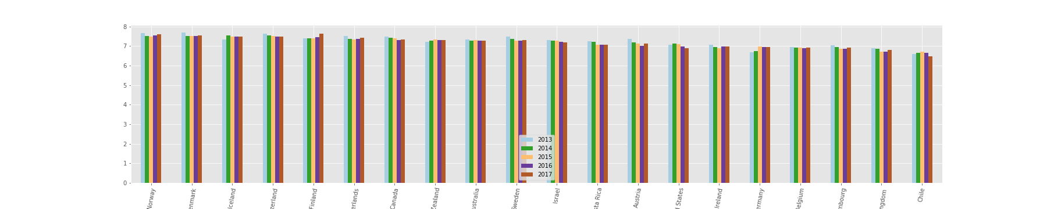

Figure Happiness Scores Over Time

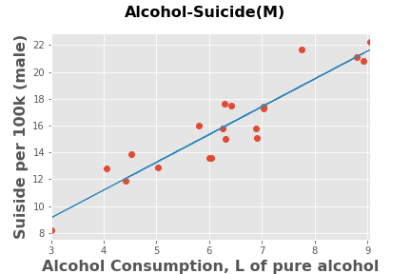

Figure Alcohol Consumption and Suicide

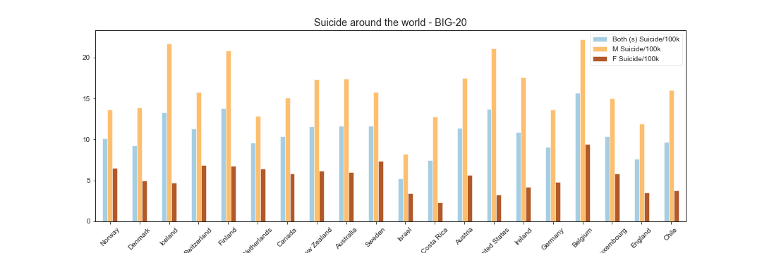

Figure Suicide Rates